Table of Contents
Matt Baker – Week 4 Individual Logbook Evidence Discussion 2
Experience 2
Reflection 2
Action 2
Matt Baker – Week 10 Individual Logbook Evidence Discussion 2
Experience 2
Reflection 2
Action 3
Appendices 4
Appendix Xx – Matt Baker Week 4 Individual Logbook Evidence 4
Hours Breakdown 6
Completed Content/Documentation 7
Team Meetings 7
Advisor Meetings 7
Client Meetings 7
Research 7
Documentation 8
Development 8
Appendix Xx – Matt Baker Week 10 Individual Logbook Evidence 9
Hours Breakdown 11
Completed Content/Documentation 12
Team Meetings 12
Advisor Meetings 12
Client Meetings 13
Research 13
Documentation 13
Testing 14
Development 19

Matt Baker – Week 4 Individual Logbook Evidence Discussion
This discussion relates to the evidence present in Appendix Xx – Matt Baker Week 4 Individual Logbook Evidence

Experience
I desired to lead by example and inspiration the entire way through this project by creating my logs with the most consistent, comprehensive, and well documented practice. Within the context of week 4, despite there not being enough work, I established and maintained timestamps and formatting that would carry through the entire project, including providing the hours per activity making adding up the hours at the end of the week easier.

Reflection
I didn’t get enough hours; I had not created enough work for myself in the week. Leading by example means doing more and higher quality work than everyone else, and on top of that, having the most reliable documentation the team would use to benchmark when it came time to audit these logs during a meeting.

Action
I made a commitment around this point to always attempt to get more hours than I got in the previous week. The hours of work I do is a variable under my control, the final outcome of a project involving four people is not. This could serve as a primary factor as to why my logs are paid attention to in the team.

Matt Baker – Week 10 Individual Logbook Evidence Discussion
This discussion relates to the evidence present in Matt Baker – Week 10 Individual Logbook Evidence Discussion

Experience
Creating and uploading these logs was an exercise in discipline and helped me remain on track with the project. A weekly expectation makes it easier to quantify how much work is realistically able to be achieved. Week 10 was another typically development-heavy week for me as I was working on the core solutions to integrate LLMs with our 3 DFIR tools at this point and had just completed the first solution. Geoff’s input guided me to create lines to calculate and display the total input and output token costs to the user from running these scripts. This was one of the longest logbooks I had created so far.

Reflection
Creating the logbooks at this point was beyond the purposes of simply documentation. It helped me to remember what I had worked on the previous day, what I had tested and desired to work on later, what syntax to use for specific commands, and allowed me to relearn the purpose of certain commands/modules/functions from explanations in my own words. After completing the first solution and knowing I would be referencing my own logs for information as how I can develop future solutions with their contents. The logbook is very long and filled with content and screenshots, but for auditing and in the interest of integrity of work, I figured there could not be too much documentation. The logs at this point were so long that when I added up the hours, I was worried I would miss them.

Action
Knowing I had to create logs going forward with a resolution that made them easier for me to personally reference enforced a desire to write explanations with foresight. I also at this point started boldening the hourly count so that when adding up my hours I can find them easier and not potentially miss them.

Appendices

Appendix Xx – Matt Baker Week 4 Individual Logbook Evidence
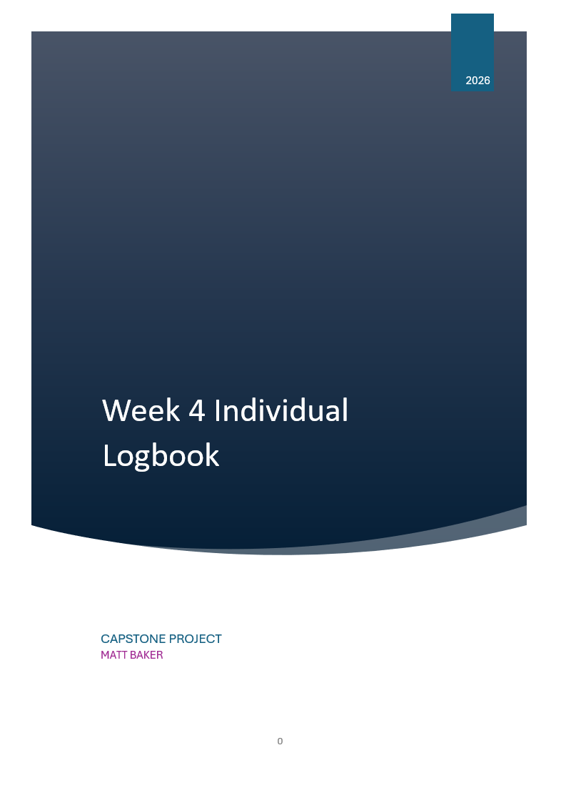

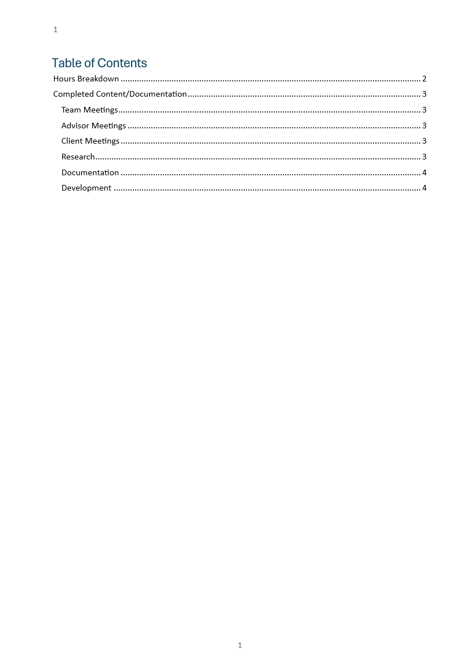

Hours Breakdown
Category | Hours completed
Team meetings | 3hrs 30 mins
Client meetings | 45mins
Advisor meetings | 1
Research | 2hrs 30 mins
Development | 1
Testing
Documentation | 7
Logbook preparation | 1
Sick leave/specific conditions
Other
Total Hours for this week | 16hrs 45min
Running total of hours completed for  Capstone | 46hrs 15min/450hr

Completed Content/Documentation

Team Meetings
Tuesday 10am-11:30am (1hr)
Attempted a meeting with Geoff, we discussed the work breakdown for the proposal instead
Friday, August 7
10:15 – 12:45 (2hrs 30 mins)
Working through the proposal with the team, generally restructuring, reformatting, and editing out/modifying irrelevant parts, ensuring everything required is in the document

Advisor Meetings
Thursday, August 6
12:00 – 1:00 (1hr)
Held our second meeting with Clement with no agenda sorted, we discussed the necessity for such things as well as signable meeting minutes to provide afterwards, the state of our project proposal, hybridization of methodologies, discussion about creating work/clarifying roles/building accountability.

Client Meetings
Wednesday, August 5
1:30-2:15 (45mins)
We held a meeting with Geoff for the purpose of documenting a meeting between client and team, including the main key problem that needs to be solved, the main expected deliverables, the “must haves”, “nice to haves” as well as the scope of the project.

Research
Wednesday, August 5
(2hrs 30mins)
Did some investigating into tool analysis efforts that follow the CTFF methodology, additionally, listened to a podcast from a 24 years’ experience forensic examiner about where AI belongs and (mostly) doesn’t belong in the IRDF pipeline

Documentation
Monday August 3rd
3:30PM-4PM (30 mins)
Added content to the project proposal, namely some description of our client and our members, as well as our roles and key responsibilities under the personnel section.
Tuesday August 4
2-4PM (2hrs)
Created the RACI matrix for the proposal, general conflict of interest statement, and updated some of the information regarding the team member’s specific roles and responsibilities.
Wednesday August 5
2:30-3:00 (30 mins)
Downloading, watching, reviewing, encoding, and uploading the edited video of our meeting with Geoff to reduce its size for upload.
3:30-4PM (30 mins)
Merged my parts of the proposal with the main document, appended and formatted the client contract.
Friday August 7
9:00 – 10:15 (1 hr 15)
Consolidating the work on our proposal so far, merging the tasks Sam and Olivia had worked on, formatting the document, and adding references
Thursday, August 6
2:00-4:15 (2hrs 15mins)
Created a template for meeting minutes and meeting agendas for advisor meetings specifically, digitized our meeting with clement, updated our week 3 minutes, and created a hierarchy for them in the git repo.

Development
Monday August 3rd
2:30PM -3:30PM (1hr)
The team collectively troubleshooted and tested access to the git repository, I added some files I was storing locally, and these commits are visible on the git.

Appendix Xx – Matt Baker Week 10 Individual Logbook Evidence
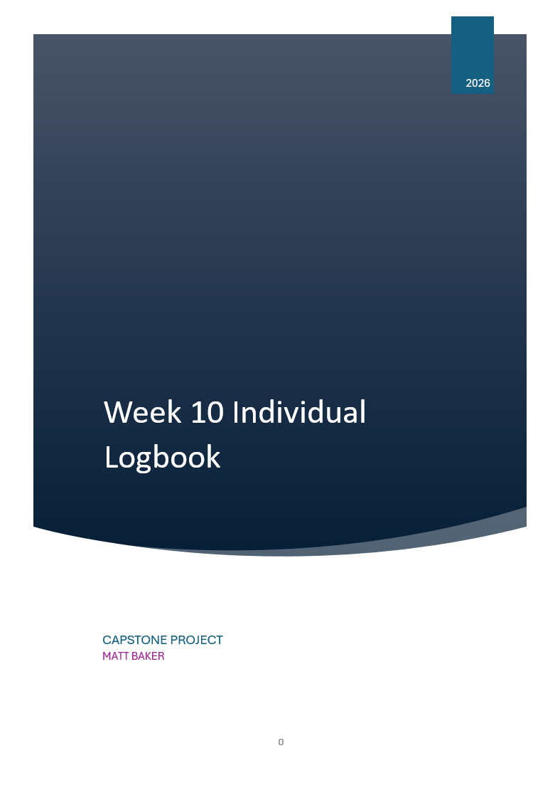

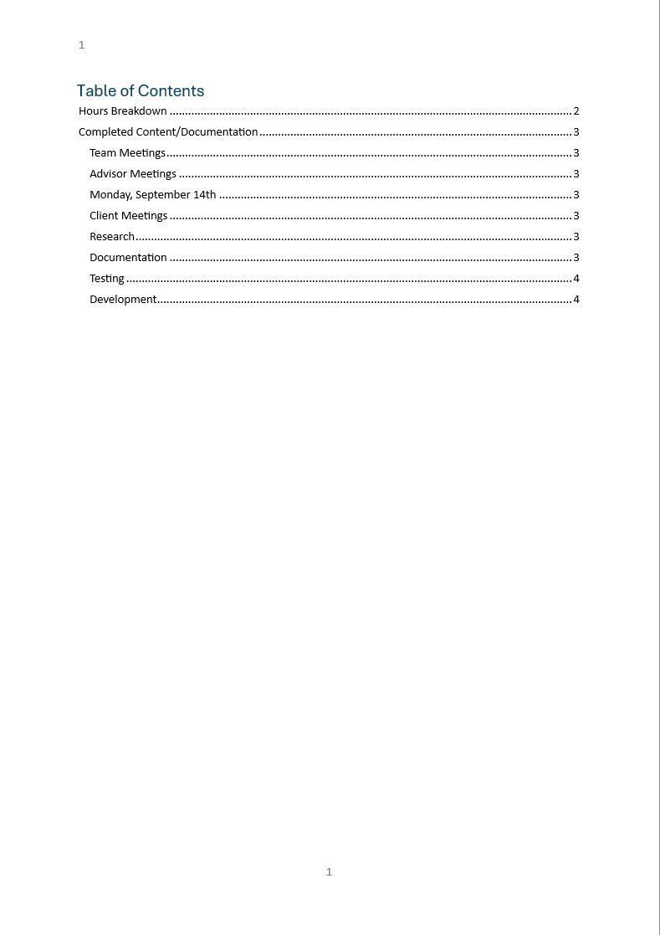

Hours Breakdown
Category | Hours completed
Team meetings | 4hrs
Client meetings | 1hr 15 min
Advisor meetings | 5hrs 15min
Research | 2hrs 45min
Development | 7hrs 30 min
Testing | 5hrs
Documentation | 2hrs 45min
Logbook preparation | 1 hr
Sick leave/specific conditions
Other
Total Hours for this week | 29hrs 30min
Running total of hours completed for  Capstone | 244hrs 30min/450hrs

Completed Content/Documentation

Team Meetings
Tuesday, September 15th
10:00 – 2:00PM (4hrs)
Audited logs clarified exact meeting hours. Discussed who would discuss each slide, did a test run through presentation, managed the git repository somewhat. Sam mentioned that some “PrivSec” guys were interested in similar technology to that which we are investigating/producing. We collectively refined the presentation, and I showed everyone how I would demonstrate both tools. We discussed the options for reducing/expanding the size of the presentation in post. We also noticed that the due date of the progress presentation differs in the upload point to its description.
Advisor Meetings
Monday, September 14th
8-10PM (2hrs)
Bryce went over our presentation, gave us some advice for each section, we discussed the inclusion of recent developments of nMap script, when and how he might demonstrate/share his existing solution of an AI-augmented nMap analysis script. He demonstrated his network tunnelling through ssh and remote viewer that in future may allow us to access resources on his network.
11-12PM (1hr)
We spoke to clement about upcoming presentation, progress on the project and confidence, discussed options for dealing with the issue of Sam and Dave’s missed weekly logs. We discussed how to document the project management portion of the project.
Friday, September 18th
9:00 – 11:15AM (2 hours 15 min)
Meeting with Bryce, all present, discussing the self management review, other upcoming academic documents. We talked about black swan events, Stuxnet, 9/11, panamax containers, suez crisis (2021). We discussed solutions to logbook issue. 5R/STARR/5w1h reflection frameworks. Talking about permissions and usage of Wireshark and nmap. Also talked to him without dave present about how to produce a pre – engagement report which is relevant to the project because we are asking for permission from Geoff to scan the network with nMap.

Client Meetings
Tuesday, September 15th
2:30 – 3:45PM (1hr 15)
Actually meeting with Geoff, giving presentation. Discussion after about the progress of the project, permission to do nmap/wireshark scanning on school network. Discussion about limitations of AI.

Research
2hrs 45 min (see research log)

Documentation
Tuesday, September 15
5:00 – 7:15 (2hrs 15 min)
Editing, rendering, and encoding the video of the presentation we presented to Geoff. Geoff asked a lot of questions and the answering + discussion was extensive, so I included the best sections/questions. Mixing the audio (my audio was originally much higher than everyone else) was a necessary fix. I also then had to watch the video (all 15 mins) back to make sure it all sounded right.
Sunday, September 20
12:00 – 12:30 (30mins)
Created and uploaded my individual evidence of contribution to the proposal.

Testing
Wednesday, September 16
12:00 – 2:15PM (2hrs 15 min)
Based on Geoff’s question, I seek to figure out if its possible to calculate the token cost with my Foremost script. I also want to experiment with JSON formats.
Using –verbose flag shows token count and other metrics, but these statistics appear in the observer’s cli directly, I want to be able to add these up into a total token count of the ran script.
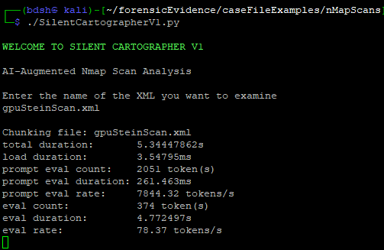
IT appears that possibly the best way to do this might to be to use capture_output subprocess feature, which hopefully works while also generating the scan chunks.
Setting the output of the first chunking command to a variable (1) with output captured directly (2) and printed out immediately after to test (3)
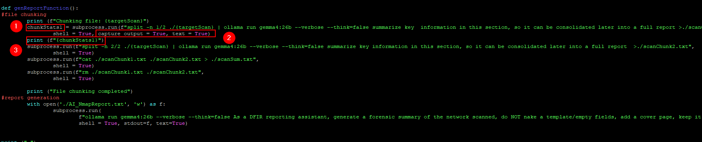
The stats are included in the variable, but python/subprocess doesn’t like 3 different types of output.
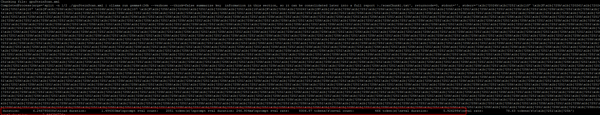
Instead of displaying as a variable, displaying as stderr, only displays what was captured by “capture_output”, which only includes the –verbose information. I also tested with stdout, because both are captured by “capture_output”, but that line did not print anything.
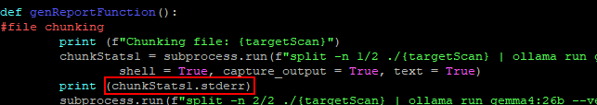
Only information I can find is that in container env, ollama outputs logs to stderr, which must include diagnostic info such as token counts.
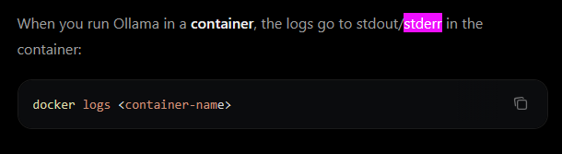
Now all I need to do it save them as an input and add them up. Because the –verbose flag contains lots of data, it will be hard to collect only the token info, I could append this text to the chunkSum.txt and have the AI calculate it, or I could collect the “prompt eval count”(input) and “eval count”(output) individually somehow.

Saturday, September 19
2:45PM – 3:30PM (45 mins)
Installing and testing an xml-JSON format conversion tool. Requires a venv. It took awhile to realise I needed to use the venv created in the same folder as the pcaps and install nmap2json there.
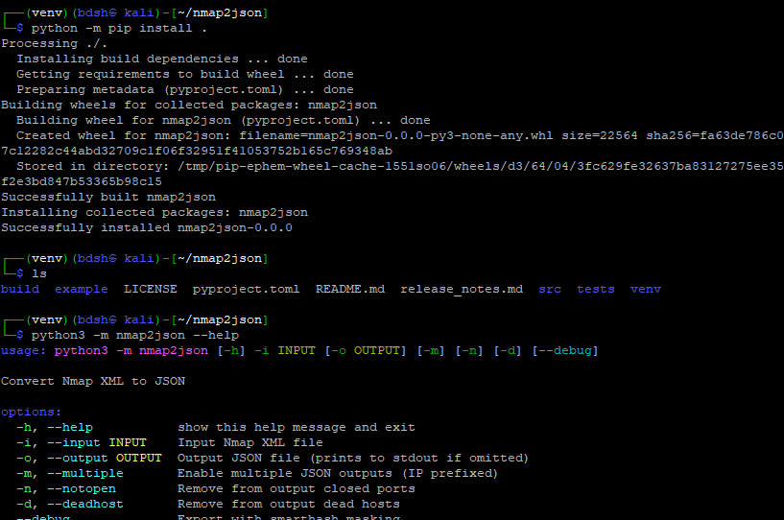
The json conversion worked, each host and its relevant ports and services is structured in a JSON list/array format.
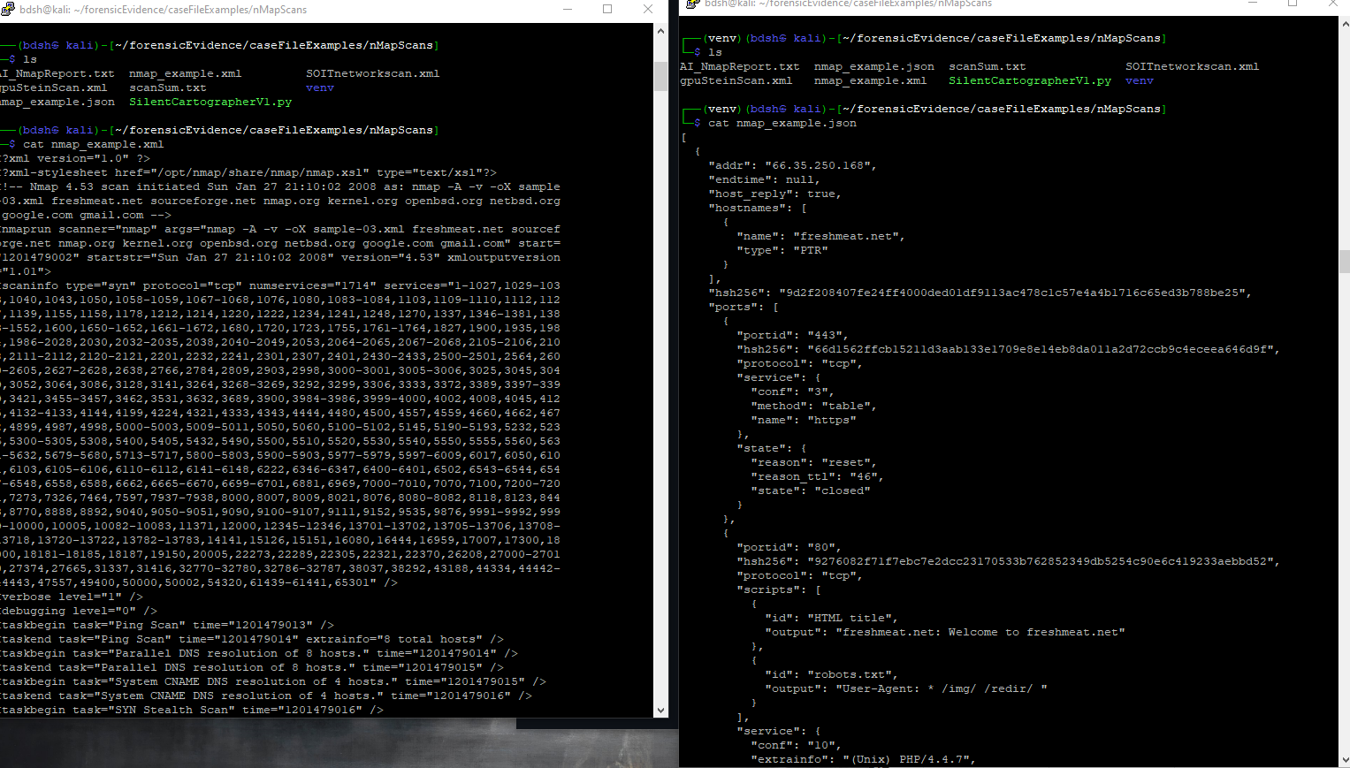

Sunday, September 20
12:45PM – 2:45PM (2hrs)
Testing different optimisations of split prompts to shorten context windows. The nmap scan of the school subnet we are permitted to scan contains massive amounts of raw data, the use of NSE sripts appends the scan with script use on every port.
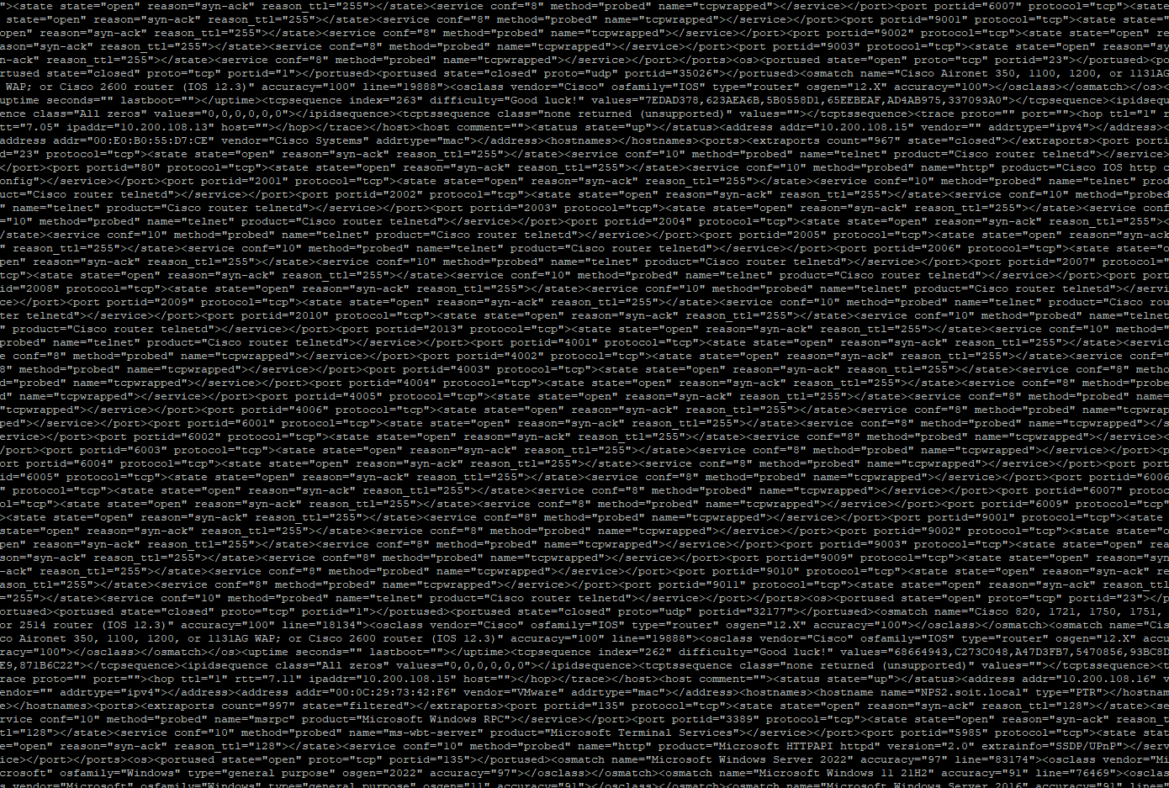
I test things like only summarizing the first two quarters.
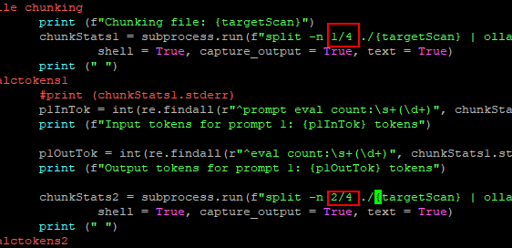

I also test the effects of different flags of the Linux “split” command, specifically on my .84 nmap scan which I know directly splits through a host name.
Consulting the manual this is the solution. It generates files instead of reading directly like using 1/2 so the code will have to be modified.
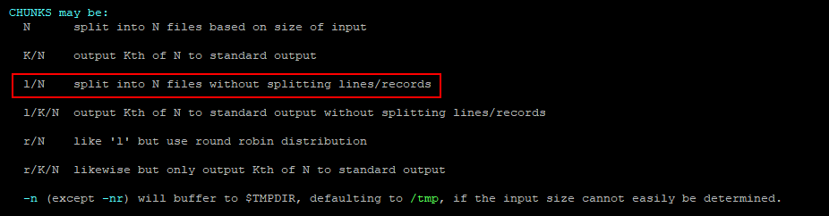
Employing this new command (1) creates 2 chunks (2) which when inspected with cat reveal the final line of the chunk will not be split on the line based on its bytes (3), preserving the actual hostname
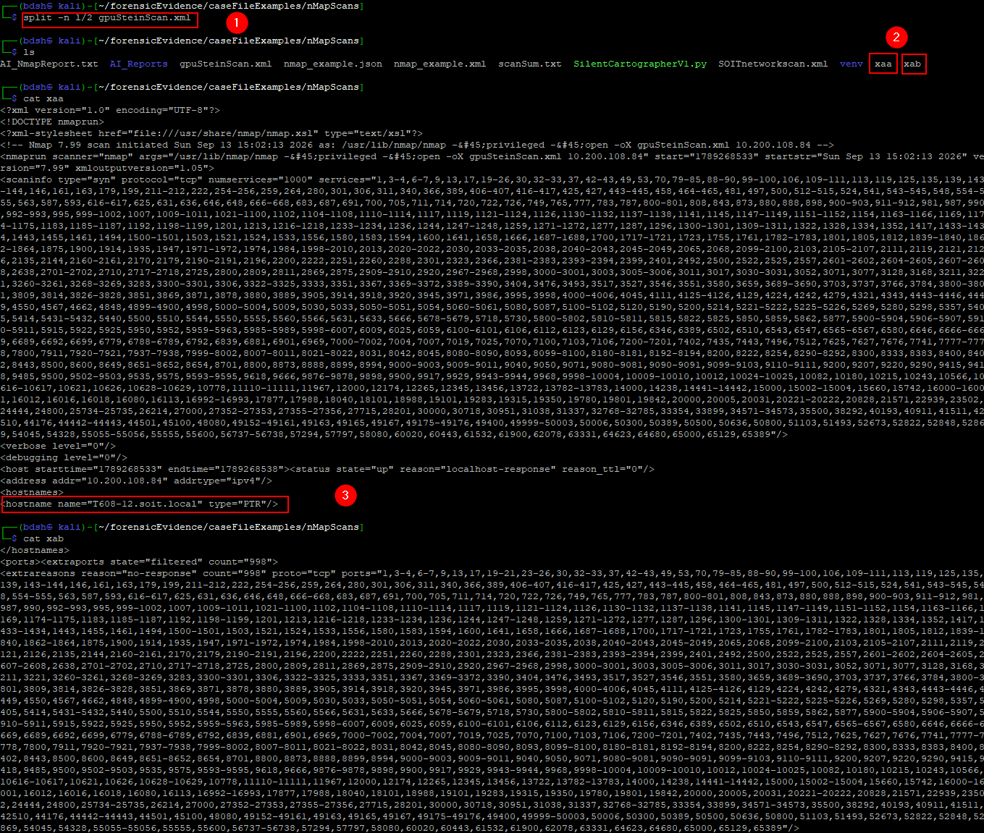
This will be implemented later.

Development
Saturday, September 19
4:00PM – 9:15PM (5hrs 15 min)
Development on SilentCartographerV1, adding up the input and output token counts for each prompt. The –verbose output from ollama is in string format so I had to figure out how to convert just the parts I want (eval and prompt_eval) token counts and add them together using “re” for regular expression modules.
https://stackoverflow.com/questions/4703390/how-to-extract-a-floating-number-from-a-string

new function couldn’t access chunkStats variables from the main function.
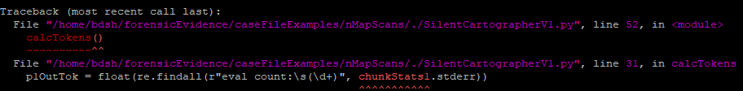
I fixed by returning them from the main function and passing them in as variables to the calctokens function. This makes the code unnecessarily complicated and although I wanted more than 1 function the calculation of total tokens might as well be in the same function they are collected from.
This was the code that used the secondary function, with changes highlighted
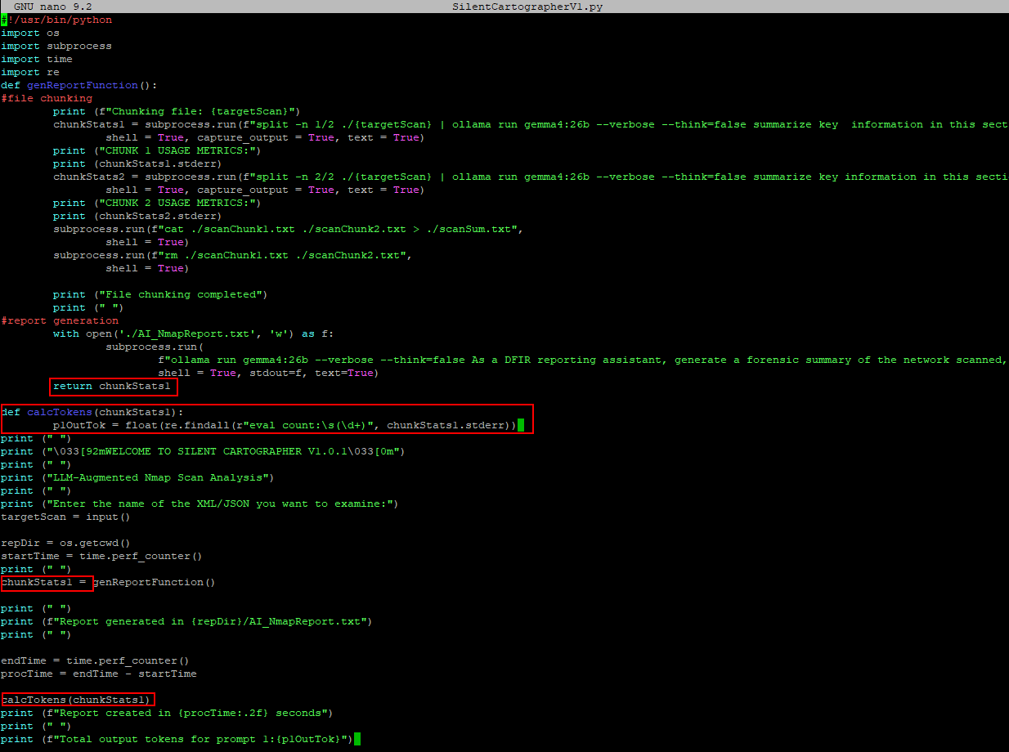
Also got this error, due to my command using “findall” which looks for the target data in lists I believe? I also realise at this point that token counts are actually round numbers (int), it’s the rates that are floats.
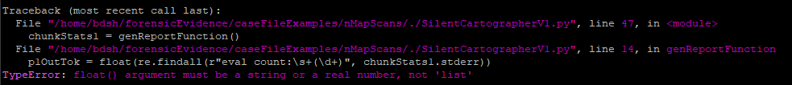
So the output of findall is a list, which means I need to specify that I want the first number in the list [0]
https://stackoverflow.com/questions/4289331/how-to-extract-numbers-from-a-string-in-python
Working line to extract the output token integer from the –verbose string variable
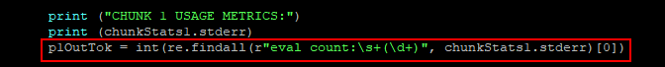
It successfully extracts the number that follows “eval count:” however, this will include the input token count “prompt eval count” (1) and display it as output token count “eval count” (2) so I have to find a way to extract the number following a string that ignores the previous “prompt” word.
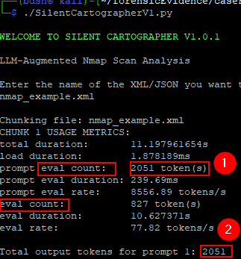

The ^ symbol means the scrutinized pattern has to start on a new line in MULTILINE mode (https://docs.python.org/3/library/re.html)
This new code successfully only matches a string after a new line, and so finds the explicit “eval count” pattern.
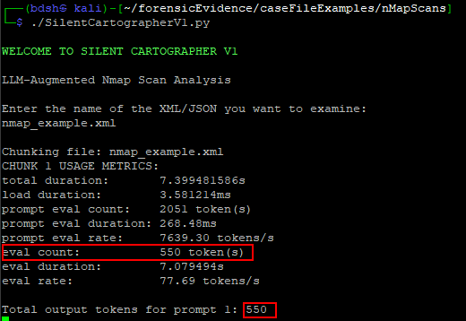
Yay it really works
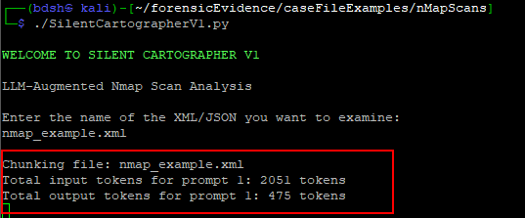
An issue I knew I would run into and took awhile to remedy is retrieving the token count for the main prompt, as I have to use “stdout” (2) to write to the main AI report (1) as f (3). And I cannot use “capture output”(4) to save the variable that saves the –verbose output as a variable (5) for processing into total token counts.
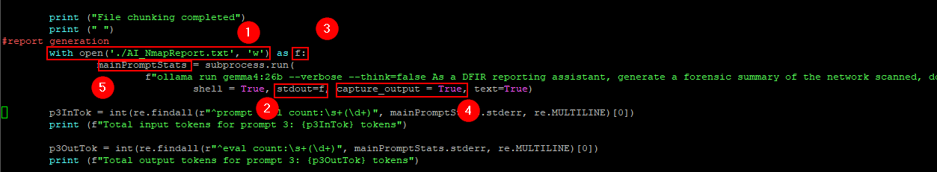

The solution was to write to the text file using stdout as f from outside of the subprocess task
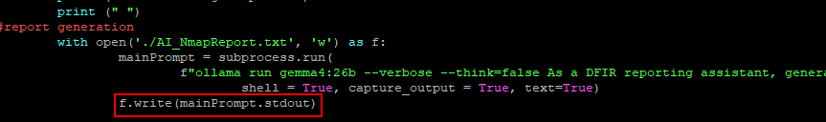
Script successfully both writes to the AI report of the summarised chunks from stdout(2) and saves the tokens from the stderr of all 3 prompts (1) although it seems like maybe prompt 1 and 2 are taking their token count from the same place, or they just happen to be identical (will troubleshoot)
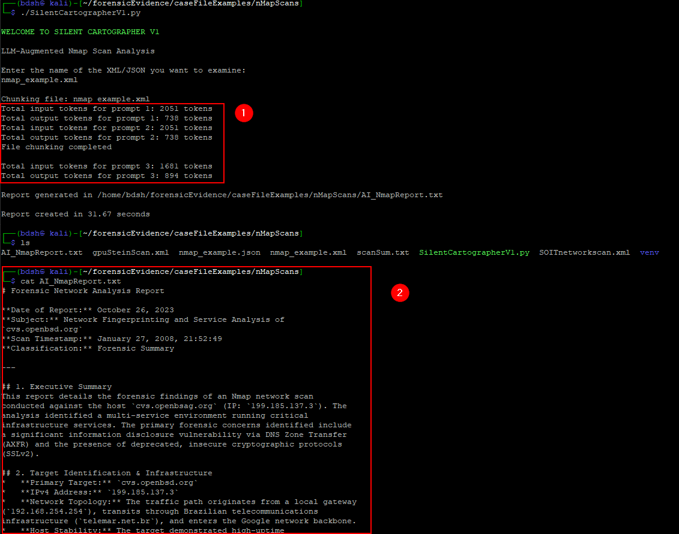

As suspected, the token counts for the first prompt (1) appear to pass via stderror extraction to both prompt 1’s token count (2) and prompt 2’s token count (3) despite the output tokens being only 445 for prompt 2 (4)
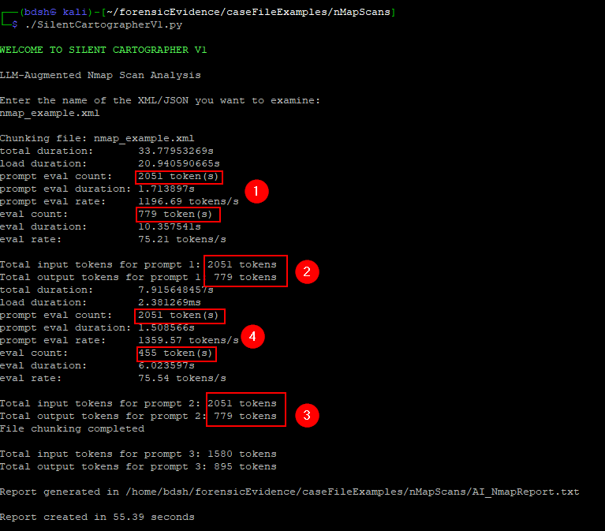
Oh woops I was printing prompt 1’s output tokens again, silly me copy pasting.
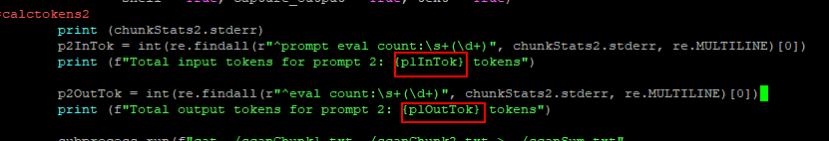

Script working as intended, with I/O token counts, now I just need to have them add together and leave the function.
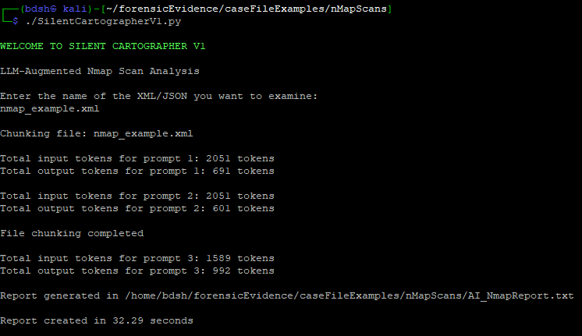
Added lines to add together the total input and output token counts as variables, then send them outside the function.
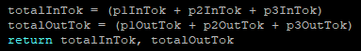
Outside of the function, have the script receive these variables when calling it (1) then print the total input, output, and calculated overall sum token count.
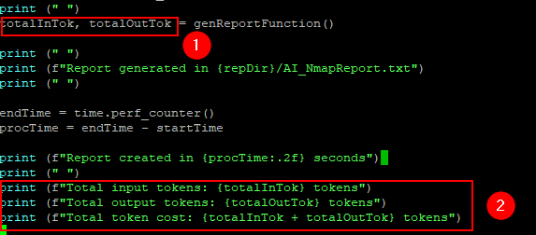
I also created a backup for all the existing scripts so far and moved them to the github.

Final output with total calculated input and output tokens. I will probably comment out the prompt-by-prompt token counts, as that was mostly for development/troubleshooting.
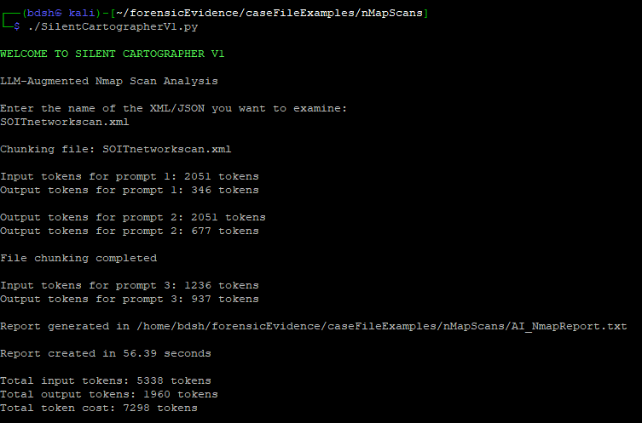
Sunday, September 20
4:15 – 6:30 (2hrs 15 mins)
Development and testing of AI reporting script for Nmap. Included the new splitting method, which uses “split -n L/2 {file}” to split a file without splitting lines to keep content intact.

Instead of directly conducting the split command and then displaying the first and second chunks to the prompt, the chunks are now generated separately (1) saved as “xaa” and xab”. Then each prompt reads the files generated respectively (2) (3).
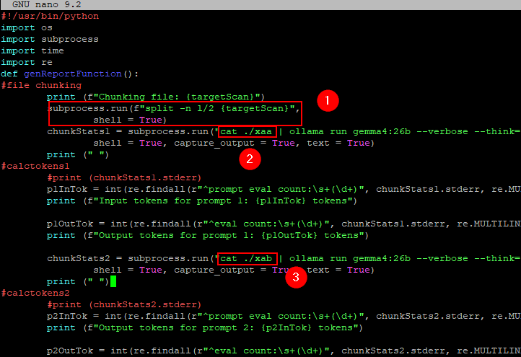
I can tell it was successful because now the output report preserves the full hostname of the target PC “T608-12.soit.local”
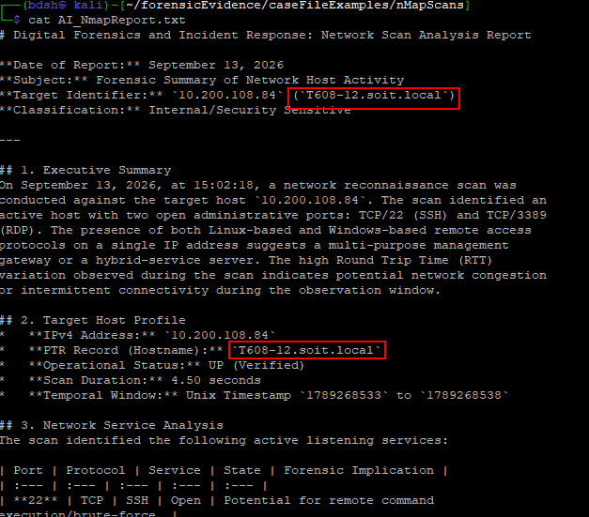
I also modified and experimented with different prompts. As the LLM sometimes doesn’t realise that its looking at an nmap scan, and it places emphasis on irrelevant data. I also want to test the team’s custom low-temperature gemma4 version.

